# SQL – Assignment 3

**Question:**

Login SQL Server and create database name EMS, run below script to generate tables:

CREATE TABLE [dbo].[Employee](

[EmpNo] [int] NOT NULL,

[EmpName] [nchar](30) COLLATE

SQL_Latin1_General_CP1_CI_AS NOT NULL,

[BirthDay] [datetime] NOT NULL,

[DeptNo] [int] NOT NULL,

[MgrNo] [nchar](10) COLLATE

SQL_Latin1_General_CP1_CI_AS NOT NULL,

[StartDate] [datetime] NOT NULL,

[Salary] [money] NOT NULL,

[Status] [int] NOT NULL,

[Note] [nchar](100) COLLATE

SQL_Latin1_General_CP1_CI_AS NULL,

[Level] [int] NOT NULL

) ON [PRIMARY]

GO

ALTER TABLE Employee

ADD CONSTRAINT PK_Emp PRIMARY KEY (EmpNo)

GO

ALTER TABLE [dbo].[Employee] ADD CONSTRAINT [chk_Level] CHECK (([Level]=(7) OR [Level]=(6) OR [Level]=(5) OR [Level]=(4) OR [Level]=(3) OR [Level]=(2) OR [Level]=(1)))

GO

ALTER TABLE [dbo].[Employee] ADD CONSTRAINT [chk_Status] CHECK (([Status]=(2) OR [Status]=(1) OR [Status]=(0)))

GO

ALTER TABLE [dbo].[Employee]

ADD Email NCHAR(30)

GO

ALTER TABLE [dbo].[Employee]

ADD CONSTRAINT chk_Email CHECK (Email IS NOT NULL)

GO

ALTER TABLE [dbo].[Employee] ADD CONSTRAINT chk_Email1 UNIQUE(Email)

GO

ALTER TABLE Employee

ADD CONSTRAINT DF_EmpNo DEFAULT 0 FOR EmpNo

GO

ALTER TABLE Employee

ADD CONSTRAINT DF_Status DEFAULT 0 FOR Status

GO

CREATE TABLE [dbo].[Skill](

[SkillNo] [int] IDENTITY(1,1) NOT NULL,

[SkillName] [nchar](30) COLLATE

SQL_Latin1_General_CP1_CI_AS NOT NULL,

[Note] [nchar](100) COLLATE

SQL_Latin1_General_CP1_CI_AS NULL

) ON [PRIMARY]

GO

ALTER TABLE Skill

ADD CONSTRAINT PK_Skill PRIMARY KEY (SkillNo)

GO

CREATE TABLE [dbo].[Department](

[DeptNo] [int] IDENTITY(1,1) NOT NULL,

[DeptName] [nchar](30) COLLATE

SQL_Latin1_General_CP1_CI_AS NOT NULL,

[Note] [nchar](100) COLLATE

SQL_Latin1_General_CP1_CI_AS NULL

) ON [PRIMARY]

GO

ALTER TABLE Department

ADD CONSTRAINT PK_Dept PRIMARY KEY (DeptNo)

GO

CREATE TABLE [dbo].[Emp_Skill](

[SkillNo] [int] NOT NULL,

[EmpNo] [int] NOT NULL,

[SkillLevel] [int] NOT NULL,

[RegDate] [datetime] NOT NULL,

[Description] [nchar](100) COLLATE

SQL_Latin1_General_CP1_CI_AS NULL

) ON [PRIMARY]

GO

ALTER TABLE Emp_Skill

ADD CONSTRAINT PK_Emp_Skill PRIMARY KEY (SkillNo, EmpNo)

GO

ALTER TABLE Employee ADD CONSTRAINT [FK_1] FOREIGN KEY([DeptNo])

REFERENCES Department (DeptNo)

GO

* 1. Add at least 8 records into each created tables.
     + Department:
       - SQL coding:

“

GO

INSERT INTO [dbo].[Department]([DeptName], [Note])

VALUES(N'Nhân Sự', 'Phòng nhân sự')

INSERT INTO [dbo].[Department]([DeptName],[Note])

VALUES(N'Khách Hàng', N'Phòng chăm sóc khách hàng')

INSERT INTO [dbo].[Department]([DeptName], [Note])

VALUES(N'Kế Toán', N'Phòng kế toán')

INSERT INTO [dbo].[Department]([DeptName], [Note])

VALUES(N'Marketing', N'Phòng marketing')

INSERT INTO [dbo].[Department]([DeptName], [Note])

VALUES(N'Phát Triển Phần Mềm', N'Bộ phận Phát triển phần mềm')

INSERT INTO [dbo].[Department]([DeptName], [Note])

VALUES(N'Kiểm Thử Phần Mềm', N'Bộ phận Kiểm thử phần mềm')

INSERT INTO [dbo].[Department]([DeptName], [Note])

VALUES(N'Bảo Trì Phần Mềm', N'Bộ phận Bảo trì phần mềm')

INSERT INTO [dbo].[Department]([DeptName] ,[Note])

VALUES(N'Cài đặt Phần Mềm', N'Bộ phận Cài đặt phần mềm')

“

* + - * Result:

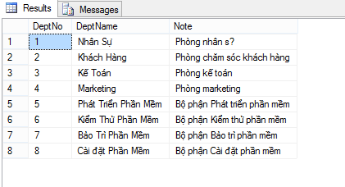s

* + - Employee:
      * SQL coding:

“

GO

INSERT INTO [dbo].[Employee]([EmpNo], [EmpName], [BirthDay], [DeptNo], [MgrNo], [StartDate], [Salary], [Level], [Status], [Note], [Email])

VALUES(1,N'Nguyễn Văn A', '02/19/1993', 1, 0, '08/19/2014', 10000000, 2, 0, N'Nhân vật hư cấu', anv@gmail.com')

INSERT INTO [dbo].[Employee]([EmpNo], [EmpName], [BirthDay], [DeptNo], [MgrNo], [StartDate], [Salary], [Level], [Status], [Note], [Email])

VALUES(2,N'Nguyễn Văn B', '08/19/1991', 4, 1, '08/19/2013', 11000000, 1, 0, null, 'bnv@gmail.com')

INSERT INTO [dbo].[Employee]([EmpNo], [EmpName], [BirthDay], [DeptNo], [MgrNo], [StartDate], [Salary], [Level], [Status], [Note], [Email])

VALUES(3,N'Nguyễn Văn C', '06/19/1993', 3, 1, '08/19/2014', 25000000, 5, 0, N'Nhân viên xuất sắc', 'cnv@gmail.com')

INSERT INTO [dbo].[Employee]([EmpNo], [EmpName], [BirthDay], [DeptNo], [MgrNo], [StartDate], [Salary], [Level], [Status], [Note], [Email])

VALUES(4,N'Nguyễn Văn D', '07/19/1992', 1, 1, '08/19/2015', 8000000, 3, 0, N'Sắp bị đuổi', 'dnv@gmail.com')

INSERT INTO [dbo].[Employee]([EmpNo], [EmpName], [BirthDay], [DeptNo], [MgrNo], [StartDate], [Salary], [Level], [Status], [Note], [Email])

VALUES(5,N'Nguyễn Văn E', '08/19/1993', 2, 1, '08/19/2014', 14000000, 5, 0, N'Chuẩn bị nghỉ hưu', 'env@gmail.com')

INSERT INTO [dbo].[Employee]([EmpNo], [EmpName], [BirthDay], [DeptNo], [MgrNo], [StartDate], [Salary], [Level], [Status], [Note], [Email])

VALUES(6,N'Nguyễn Văn F', '08/19/1993', 4, 1, '08/19/2014', 14000000, 4, 0, N'Chuẩn bị nghỉ hưu', 'fnv@gmail.com')

INSERT INTO [dbo].[Employee]([EmpNo], [EmpName], [BirthDay], [DeptNo], [MgrNo], [StartDate], [Salary], [Level], [Status], [Note], [Email])

VALUES(7,N'Nguyễn Văn G', '02/19/1992', 2, 1, '08/19/2014', 14000000, 6, 0, N'Nhân viên xuất sắc', 'gnv@gmail.com')

INSERT INTO [dbo].[Employee]([EmpNo], [EmpName], [BirthDay], [DeptNo], [MgrNo], [StartDate], [Salary], [Level], [Status], [Note], [Email])

VALUES(8,N'Nguyễn Văn H', '08/19/1993', 2, 1, '08/19/2014', 14000000, 3, 0, null, 'hnv@gmail.com')

“

* + - * Result:

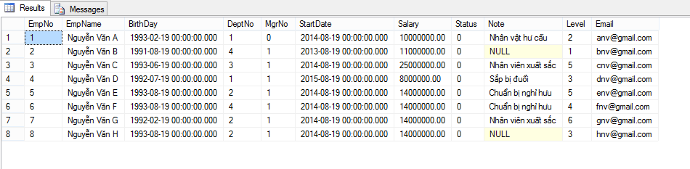

* + - Skill:
      * SQL coding:

“

GO

INSERT INTO [dbo].[Skill]([SkillName], [Note])

VALUES(N'Đàm Phán', N'Thường ở bộ phận chăm sóc khách hàng')

INSERT INTO [dbo].[Skill]([SkillName], [Note])

VALUES(N'C++', N'Thường ở bộ phận Phát triển phần mềm')

INSERT INTO [dbo].[Skill]([SkillName], [Note])

VALUES(N'.Net', N'Thường ở bộ phận Phát triển phần mềm')

INSERT INTO [dbo].[Skill]([SkillName], [Note])

VALUES(N'Java', N'Thường ở bộ phận Phát triển phần mềm')

INSERT INTO [dbo].[Skill]([SkillName], [Note])

VALUES(N'Marketing', N'Thường ở bộ phận Marketing')

INSERT INTO [dbo].[Skill]([SkillName], [Note])

VALUES(N'PHP', N'Thường ở bộ phận Phát triển phần mềm')

INSERT INTO [dbo].[Skill]([SkillName], [Note])

VALUES(N'HTML, CSS', N'Thường ở bộ phận Phát triển phần mềm')

INSERT INTO [dbo].[Skill]([SkillName],[Note])

VALUES(N'Database', N'Thường ở bộ phận Phát triển phần mềm')

“

* + - * Result:

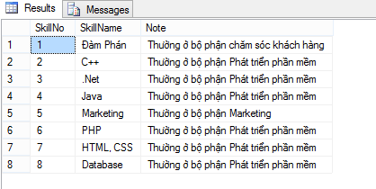

* + - Emp_Skill:
      * SQL coding:

“

GO

INSERT INTO [dbo].[Emp_Skill]([SkillNo], [EmpNo], [SkillLevel], [RegDate], [Description])

VALUES(1,1,1,'08/19/2015','note')

INSERT INTO [dbo].[Emp_Skill]([SkillNo], [EmpNo], [SkillLevel], [RegDate], [Description])

VALUES(4,2,2,'08/19/2014','note')

INSERT INTO [dbo].[Emp_Skill]([SkillNo], [EmpNo], [SkillLevel], [RegDate], [Description])

VALUES(3,3,3,'08/19/2015','note')

INSERT INTO [dbo].[Emp_Skill]([SkillNo], [EmpNo], [SkillLevel], [RegDate], [Description])

VALUES(5,4,3,'08/19/2014','note')

INSERT INTO [dbo].[Emp_Skill]([SkillNo], [EmpNo], [SkillLevel], [RegDate], [Description])

VALUES(2,3,3,'08/19/2014','note')

INSERT INTO [dbo].[Emp_Skill]([SkillNo], [EmpNo], [SkillLevel], [RegDate], [Description])

VALUES(2,2,3,'08/19/2013','note')

INSERT INTO [dbo].[Emp_Skill]([SkillNo], [EmpNo], [SkillLevel], [RegDate], [Description])

VALUES(2,4,1,'08/19/2014','note')

INSERT INTO [dbo].[Emp_Skill]([SkillNo], [EmpNo], [SkillLevel], [RegDate], [Description])

VALUES(4,3,1,'08/19/2014','note')

“

* + - * Result:

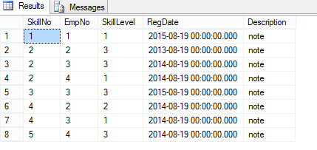

* 1. Specify name, email and department name of the employees that have been working at least six months.
     + SQL coding:

“

SELECT e.[EmpName], e.[Email], d.[DeptName]

FROM [dbo].[Employee] as e, [dbo].[Department] as d

WHERE DateDiff( MONTH, e.[StartDate] , GetDate()) >= 6 AND e.[DeptNo] = d.[DeptNo]

“

* + - Result:

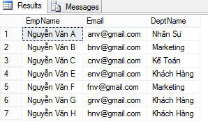

* 1. Specify the names of the employees whore have either ‘C++’ or ‘.NET’ skills.
     + SQL coding:

“

SELECT DISTINCT e.[EmpName]

FROM [dbo].[Employee] as e, [dbo].[Emp_Skill] as esk, [dbo].[Skill] as sk

WHERE sk.SkillNo = esk.SkillNo AND e.EmpNo = esk.EmpNo AND (sk.SkillName like '%C++%' OR sk.SkillName like '%.Net%')

“

* + - Result:

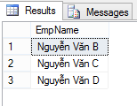

* 1. List allemployee names, manager names, manager emails of those employees.
     + SQL coding:

“

SELECT DISTINCT e.[EmpName] as [Employee Name], ISNULL(e2.[EmpName],N'Quản Lý Cao Nhất') as [Manager Name],

ISNULL(e2.[Email],e.Email) as [Manager Email]

FROM [dbo].[Employee] as e

LEFT JOIN [dbo].[Employee] as e2

ON e.MgrNo = e2.EmpNo

“

* + - Result:

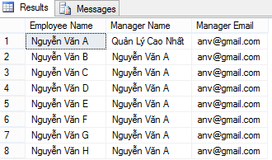

* 1. Specify the departments which have >=2 employees, print out the list of departments’ employees right after each department.
     + SQL coding:

“

GO

SELECT DISTINCT d.[DeptNo] as [Department ID], d.[DeptName] as [Department Name],

COUNT(e.[EmpNo]) as [Number Employee],

STUFF((SELECT ', '+ CAST(e1.[EmpNo] as nchar(10))

FROM [dbo].[Employee] as e1

WHERE e1.[DeptNo] = d.[DeptNo]

FOR XML PATH('')),1,2,'') as [List Employee ID]

FROM [dbo].[Department] d, [dbo].[Employee] as e

WHERE d.[DeptNo] = e.[DeptNo] AND (SELECT COUNT(e2.[EmpNo]) FROM [dbo].[Employee] as e2 WHERE e2.[DeptNo] = d.[DeptNo]) >= 2

GROUP BY d.[DeptNo], d.[DeptName]

“

* + - Result:

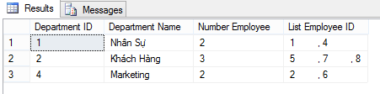

* 1. List all name, email and skill number of the employees and sortascending order by employee’s name.
     + SQL coding:

“

SELECT e.[EmpName] as [Employee Name], e.[Email] as [Employee Email], COUNT(esk.[EmpNo]) as [Skill Number]

FROM [dbo].[Employee] as e

LEFT JOIN [dbo].[Emp_Skill] esk

ON e.[EmpNo] = esk.[EmpNo]

GROUP BY e.[EmpName], e.[Email]

ORDER BY e.[EmpName] ASC

“

* + - Result:

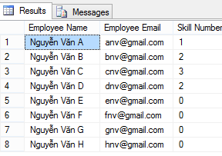

* 1. Use SUB-QUERY technique to list out the different employees (include name, email, birthday) who are working and have multiple skills.
     + SQL coding:

“

SELECT e.[EmpName] as [Employee Name], e.[Email] as [Employee Email], e.[BirthDay] as [Employee Birthday]

FROM [dbo].[Employee] as e

WHERE (SELECT COUNT(esk2.[EmpNo]) FROM [dbo].[Emp_Skill] esk2 WHERE esk2.[EmpNo] = e.EmpNo GROUP BY esk2.[EmpNo]) > 1

AND e.[Status] = 0

ORDER BY e.[EmpName] ASC

“

* + - Result:

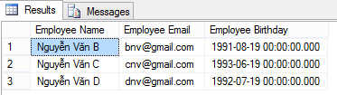

* 1. Create a view to list all employees are working (include: name of employee and skill name, department name).
     + SQL coding:

“

GO

CREATE VIEW Employee_Working

AS

SELECT e.[EmpName] as [Employee Name],

STUFF((SELECT ', '+sk.[SkillName]

FROM [dbo].[Skill] sk, [dbo].[Emp_Skill] esk

WHERE sk.[SkillNo] = esk.[SkillNo] AND esk.EmpNo = e.EmpNo

FOR XML PATH('')),1,2,'') as [Employee Skill], d.[DeptName] as [Employee Department]

FROM [dbo].[Employee] as e, [dbo].[Department] d

WHERE e.[Status] = 0 AND d.[DeptNo] = e.[DeptNo]

“

* + - Result:

